Spike outcomes
Name: Adjustable PIR Passive Infra Red Motion Detector Module HCSR501 usage and suitability.

Goals:
The sensor has a possible use in the shower sensor project because it is cheap and could be used as a part in the process of determining if whilst the shower is running, there is someone using it. The goal is to verify the suitability and learn usage.

Personnel:
Primary – Luke

Technologies, Tools, and Resources used:
- LED
- Breadboard
- Wires
- Adjustable PIR Passive Infra Red Motion Detector Module HCSR501
- Arduinobasics.blogspot.com.au/2013/12/pir-sensor-part-1.html?m=1

Tasks undertaken:
- Connected an +LED to motion sensor out pin
- Connected led ground to ground
- Connected motion sensor +5v to 5 volt power supply and ground to ground.
- Verify LED is off
  - Move in front of LED and obseve LED is on.
- Change sensitivity and Time on Delay.
  - Verify sensor behaviour is accordingly different

What we found out:
Wiring;
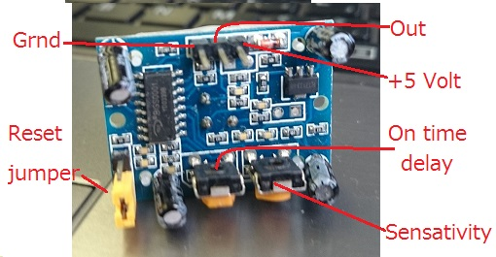

- The sensor takes +5Volts, and as such requires a separate power supply than the esp8266. Alternatively, a 5volt power supply can be used, but voltage regulated down to 3.3 after the motion sensor but before the esp8266.
- The reset jumper controls the whether or not the sensor resets after sensing movement. If the jumper is in the top position (h) it is in auto reset mode. The sensor will then stay high until the motion stops. Otherwise, the chip will stay high even after motion stops, for the pre-set time period (set by on time delay pot).
- The out pin goes high when motion is detected.
- The on time delay is adjustable between very few and 200 seconds.
- The angle of detection seems to be around 140 degrees.
- The sensitivity adjustment pot specifically adjusts how close the movement must be.
- The on time delay pot specifically adjusts the amount of time OUT will stay high after sensing movement. After the time, it will go low again (if no movement) and wait till new movement is sensed.
- The max range is dependent on the power supply. Using 5v tended to work up to around 7 meters

Open issues/risks:
- Is it waterproof?
Recommendations:
- Build a waterproof housing and test it works through the plastic or whatever material is used.

